|  |
| --- |
| EPAM Systems, RD Dep. |
| MTN.BI.08 Core PL/SQL |

|  |  |  |  |  |  |
| --- | --- | --- | --- | --- | --- |
| REVISION HISTORY | | | | | |
| Ver. | Description of Change | Author | Date | Approved | |
| Name | Effective Date |
| 1.0 | Initial status | [Kiryl Bucha](mailto:Kiryl_Bucha@epam.com) | 12-JAN-2012 |  |  |
| 2.0 | Updated in accordance with renewed content | [Elias Nema](mailto:Elias_Nema@epam.com) | 20-JAN-2014 |  |  |
| 3.0 | Report on task | Hanna Klimovich | 02-DEC-2017 |  |  |

Contents

1. Create Packages for Reload Dimension from SA_* 3

2. Task Results 3

# Create packages to load dimensions from source to staging (3NF) layer

The Main Task is to create independent packages to load dimensions according to your DWH solution concept that was developed on Module 6 Introduction to DWH.

Required points:

* Create all required dim objects on ST Layer (T_...).
* Grant all required privileges to ST_CL (Cleansing Layer).
* Create packages to load dim data (one package = one dimension) on ST_CL.
* Use Explicit Cursor (One or more procedures).
* Use Implicit Cursor (One or more procedures).
* Use Merge (One or more procedures).

# Task Results

Create required objects:

Prepare document with description of your load and screenshot of data in the Dimension Tables.

Test Procedure for Repeatable execution (it should produce same consistent results each time on a same source data).

* To create 3nf tables:

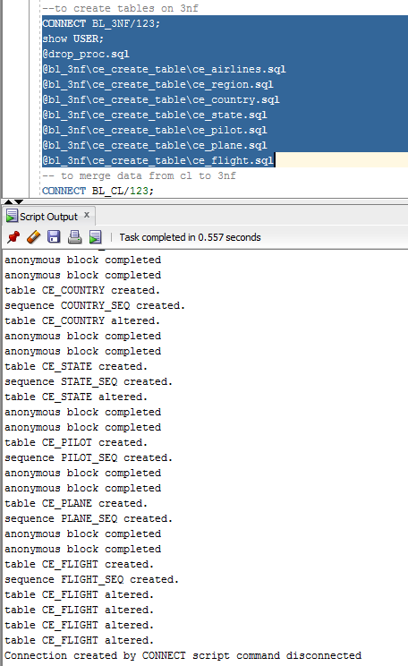

* Script example of creating 3nf_tables:

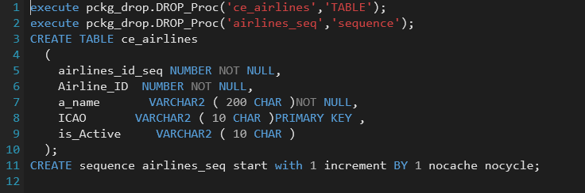

* To merge data from cl tables to 3 nf tables:

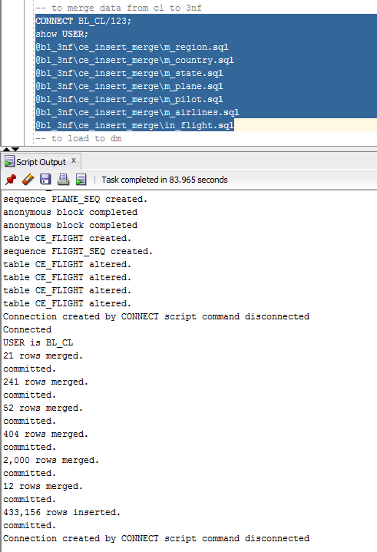

* Script example of loading to 3nf with the help of cl_to_ce_pkg.sql package:

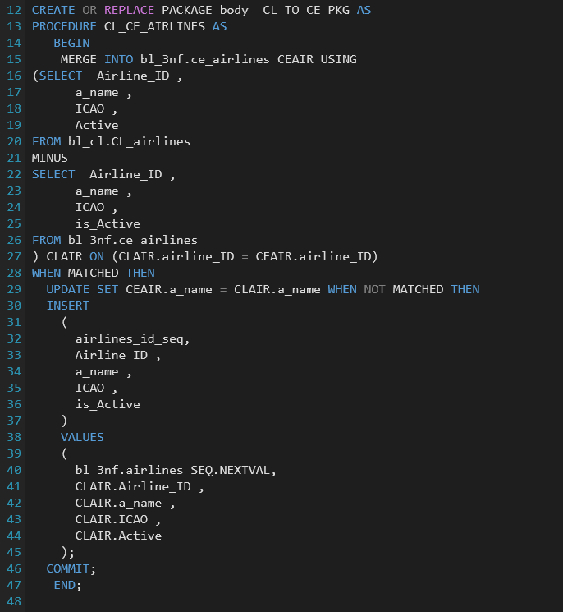

* Another way to load is by each sql file:

